**EXERCISE 1: CONTROL STRUCTURES:**

**CODE:**

**CREATING TABLES FOR THAT SCENARIO:**

BEGIN

EXECUTE IMMEDIATE 'DROP TABLE customers';

EXECUTE IMMEDIATE 'DROP TABLE loans';

EXCEPTION

WHEN OTHERS THEN NULL;

END;

/

CREATE TABLE customers (

customer_id NUMBER PRIMARY KEY,

name VARCHAR2(100),

age NUMBER,

balance NUMBER,

isvip CHAR(1) DEFAULT 'N'

);

CREATE TABLE loans (

loan_id NUMBER PRIMARY KEY,

customer_id NUMBER REFERENCES customers(customer_id),

interest_rate NUMBER,

due_date DATE

);

INSERT INTO customers VALUES (1, 'John Smith', 65, 15000, 'N');

INSERT INTO customers VALUES (2, 'Alice Brown', 45, 8000, 'N');

INSERT INTO customers VALUES (3, 'Bob Davis', 70, 5000, 'N');

INSERT INTO loans VALUES (101, 1, 7.5, SYSDATE + 10); -- Due in 10 days

INSERT INTO loans VALUES (102, 2, 8.0, SYSDATE + 45); -- Due in 45 days

INSERT INTO loans VALUES (103, 3, 6.5, SYSDATE + 20); -- Due in 20 days

COMMIT;

**SCENARIO 1:**

BEGIN

FOR loan_rec IN (

SELECT l.loan_id, l.interest_rate, c.age

FROM loans l

JOIN customers c ON l.customer_id = c.customer_id

) LOOP

IF loan_rec.age > 60 THEN

UPDATE loans

SET interest_rate = interest_rate - 1

WHERE loan_id = loan_rec.loan_id;

END IF;

END LOOP;

COMMIT;

END;

/ **OUTPUT:** 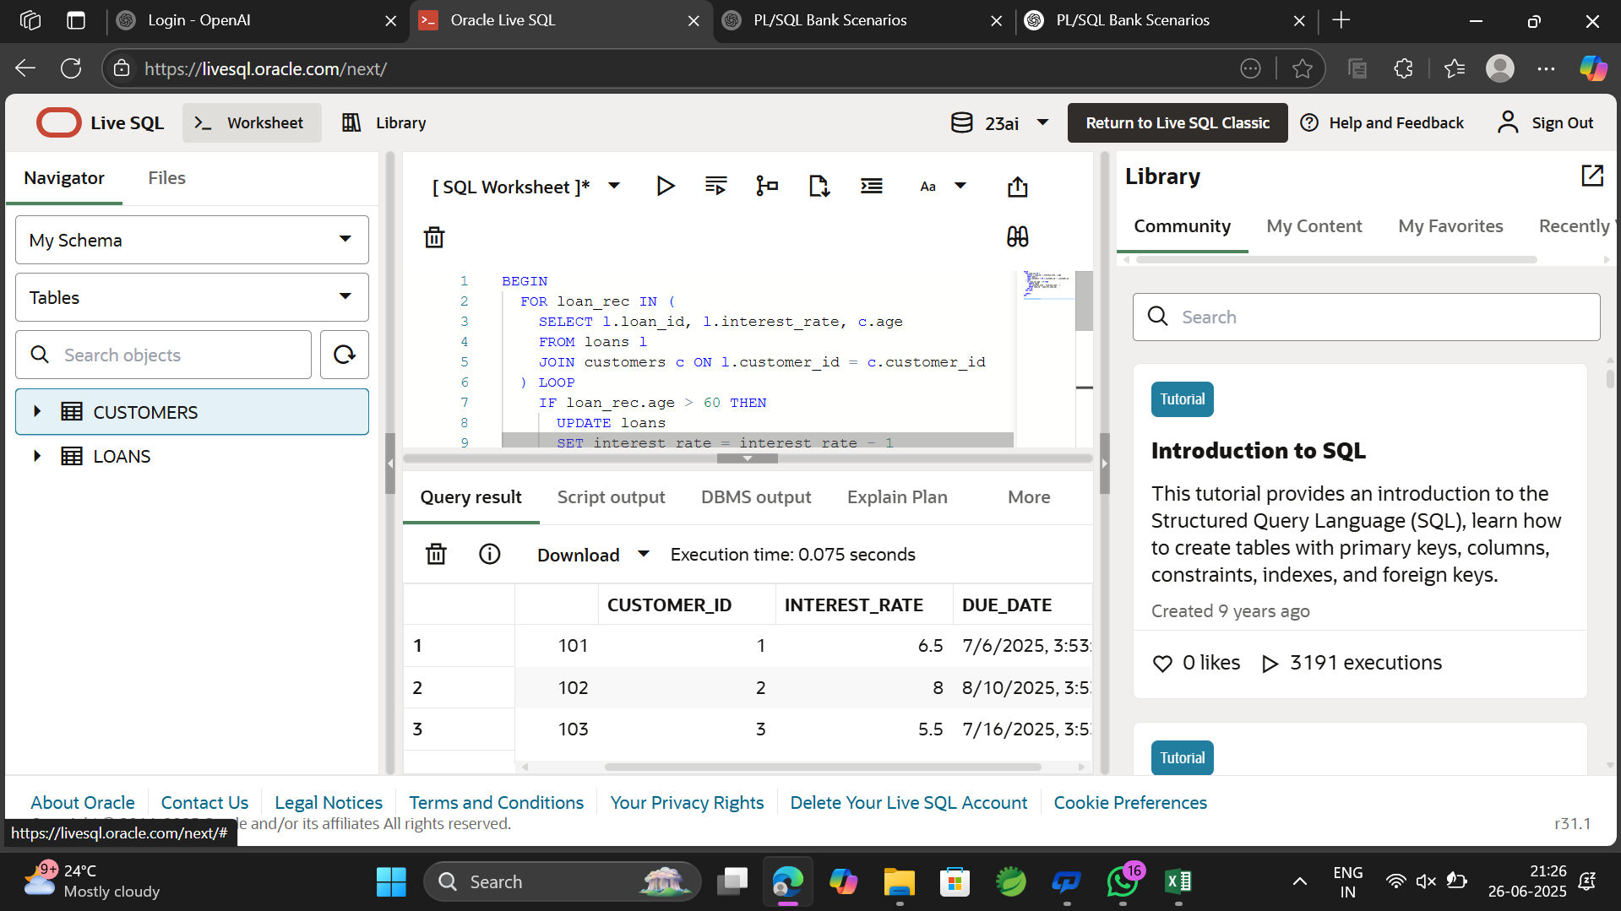

**SCENARIO 2:**

BEGIN

FOR cust_rec IN (

SELECT customer_id, balance

FROM customers

) LOOP

IF cust_rec.balance > 10000 THEN

UPDATE customers

SET isvip = 'Y'

WHERE customer_id = cust_rec.customer_id;

END IF;

END LOOP;

COMMIT;

END;

/

**OUTPUT:** 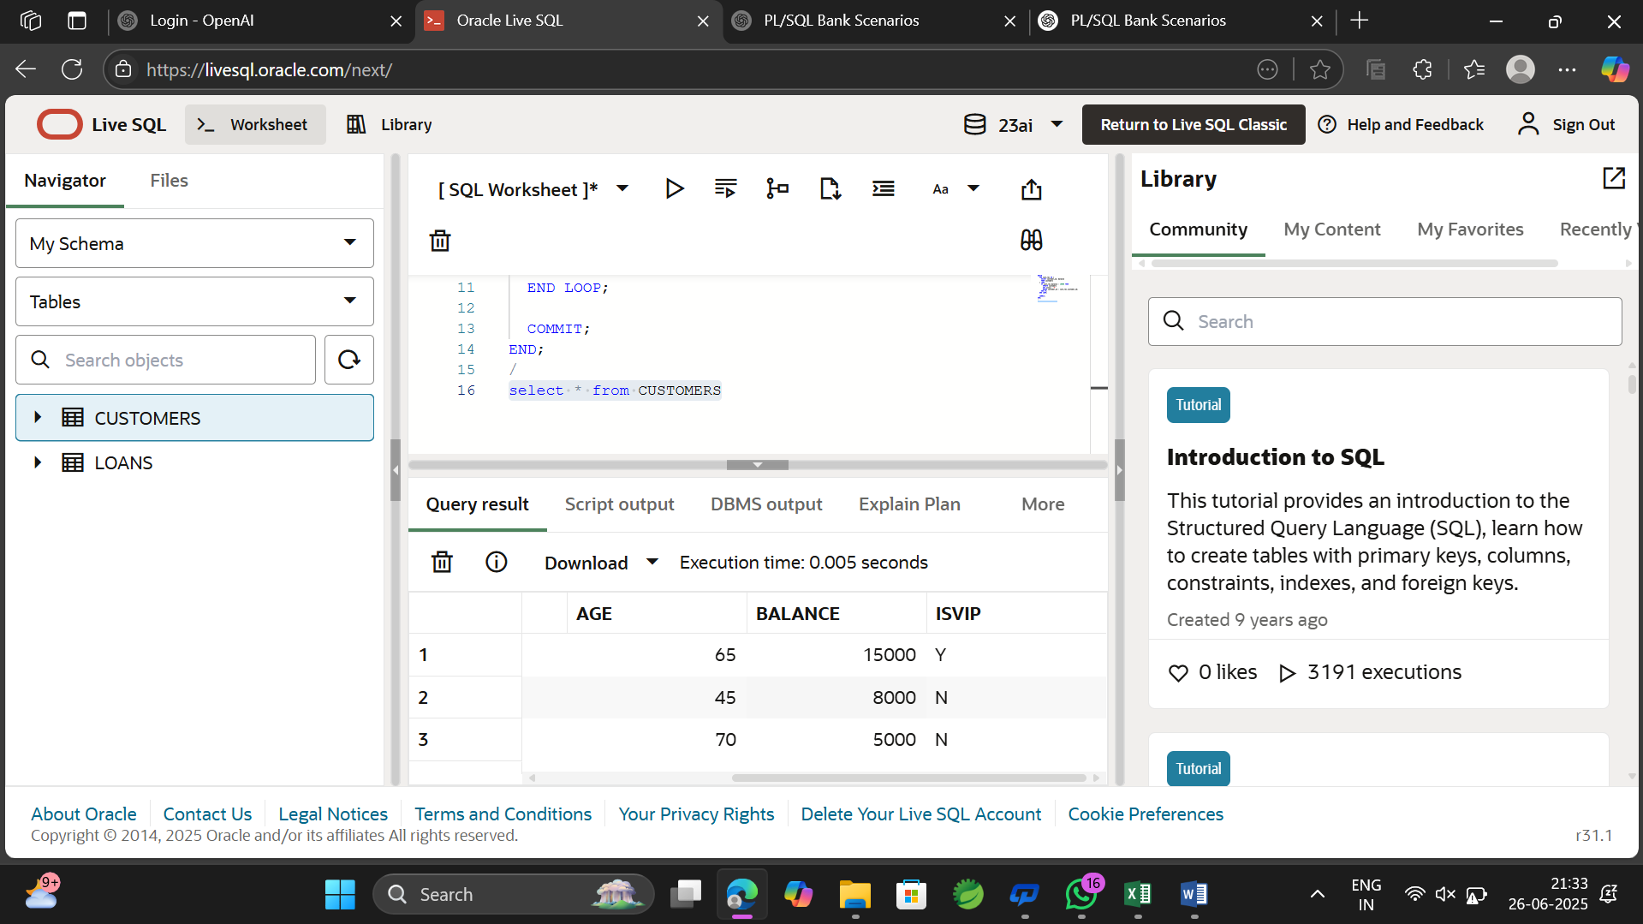

**SCENARIO 3:**

BEGIN

FOR loan_rec IN (

SELECT l.loan_id, c.name, l.due_date

FROM loans l

JOIN customers c ON l.customer_id = c.customer_id

WHERE l.due_date BETWEEN SYSDATE AND SYSDATE + 30

) LOOP

DBMS_OUTPUT.PUT_LINE('Reminder: Loan ID ' || loan_rec.loan_id ||

' for ' || loan_rec.name ||

' is due on ' || TO_CHAR(loan_rec.due_date, 'DD-MON-YYYY'));

END LOOP;

END;

/

**OUTPUT:**

